**04 – Complex Exponentials**

**Topics:** Complex exponentials as oscillatory functions, representations of complex numbers, simple AC circuit with resistor.

**Summary:** The first tasks are meant to help students gain some familiarity with complex exponentials as oscillatory solutions to differential equations. They first consider similarities and differences between exponential and trigonometric functions as solutions to a first-order equation, then similarly for the behavior of their second-derivatives. Students then perform a few basic tasks involving different representations of numbers in the complex plane, and draw conclusions about the direction of rotation over time for an arrow representing a complex exponential function. The final task applies to a simple *AC* circuit, where students must find the magnitude of the current through the resistor at a specific time.

**Written by:** Charles Baily, Steven Pollock and Michael Dubson.

**Contact:** Steven.Pollock@Colorado.EDU

**Comments:** Students should be able to complete these activities in less than 50 minutes. The first task is “simple” but seems to be necessary – we were surprised by the amount of time that some students took to find the first-derivatives of the functions given; a sign error here and there was common. In the second part, some students will again lose time concentrating only on the mathematical expressions for each individual case, and not think about how they can fill out the table by inspecting the diagram, or by recognizing the pattern. Students haven’t necessarily had problems completing the complex mathematics exercises that follow, but seem to require more practice than we’d probably anticipate in order to be comfortable with them; some will be rusty on the rules for multiplying exponentials functions. The questions about the vector rotating in the complex plane are given in anticipation of their use in future tutorials (#5-Complex Impedance, #7-Boundary Conditions, and #12-Reflection and Transmission). We’ve found this to be a very powerful visualization tool for students when working with oscillatory functions. The final task on the magnitude of the physical current will be challenging for a few students – some have shown a tendency to confuse their use of complex exponentials in quantum mechanics (multiplying by the complex conjugate to find a physical quantity) when finding the physical voltage or current represented by a complex exponential (instead of looking at just one component). In this case, instructors should be sure that students don’t think the magnitude of the physical current is simply V0/R.

**A.** Which of the following could be solutions to this first-order differential equation (where the prime denotes a time-derivative, and ω is a real number):



A) 

B) 

C) 

D) 

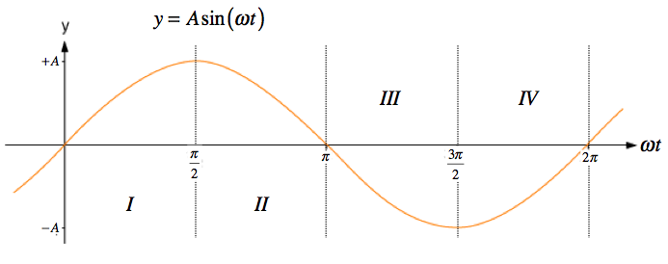

**B.** Complete the following table for the **sign** (+/–) of the functions  &  (its second time derivative), and the ratio of the two, in the four regions (I-IV) shown in the diagram above.

|  |  |  |  |  |
| --- | --- | --- | --- | --- |
| **SIGN OF:** | **I** | **II** | **III** | **IV** |
|  |  |  |  |  |
|  |  |  |  |  |
|  |  |  |  |  |

**C.** Complete the following table for the **sign** (+/–) of the ratio of the complex exponential function  & , for each of the given ranges of time.

|  |  |  |  |  |
| --- | --- | --- | --- | --- |
| **SIGN OF:** |  |  |  |  |
|  |  |  |  |  |

Compare your answers with the previous table, and comment on any similarities or differences between the two.

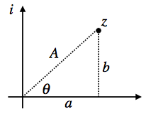**D. Euler’s Equation**



Recall that a complex number  can always be written in two ways:





 

When multiplying two complex numbers, the phase angles add:

 



Rewrite the following complex numbers in the form 

 

 

Use these last two answers and the rules for multiplying complex exponentials to find:



**E.** Identify the following complex numbers with their location in the complex plane:

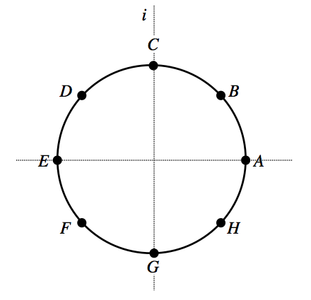









**F.** Now, do the same task for the function  at the various times given below:







Would an arrow representing  in the complex plane rotate *clockwise* or *counter-clockwise* as time advances?

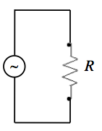

**G.** The circuit at right contains a resistor *R* and an AC voltage source, which can be represented by the following expression:



What is the magnitude of the current through the resistor at ? Explain in words how you arrived at your answer.